Exam 1:

# Character Practice:

### Unicode

Protocols

* Grapheme
* Glyph
* Rules

UTF-32

* 4 bytes only

UTF-16

* 2 or 4 byte

UTF-8

* 1 to 4 bytes

UTF-4

* No valid answer

UTF-2

* No valid Answer

UTF-1

* 1 to 5 byte

Unicodes rules used to indicate direction of a scripts writing

* True

Unicode rules used to indicate whether a substitute representations should be used when certain characters occur together

* True

Unicodes rules used to indicate whether a character should be italicized

* False

A symbol intended to represent a readable character in a particular language is a

* glyph

The smallest unit, character, punctuation, digit, etc. of a writing system is

* Grapheme

### Ebcdic

Character Size

* 8 bit

### USC

Protocols

* Grapheme

USC-16

* No valid answer

USC-4

* Only 4 byte

USC-2

* Only 2 byte

### ASCII

Character Size

* 7 bits

### Plane

**0**

* Basic Multilingual plane

**2**

* Chinese, Japanese and korean Characters/ Supplementary ideographic plane

Only [] unicode planes are currently being used (have actual code points assigned)

* 6

Unicode defines [] total planes

* 17

### Booths

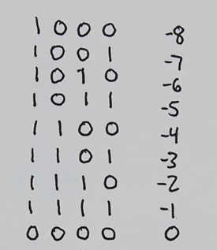

00 - do nothing

01 - add

10 - subtract

11 - do nothing

A= significant bit, First number, 4 0’s

S= significant bit, 2’s comp of 1 number, 4 0’s

P= significant bit, 4 0’s, Second number

EX:

Use Booth's algorithm and 1-bit signed storage, multiply -3 by -4

0011

1100

+1

------

1101 = -3

0100

1011

+1

-----

1100

A = 1 1101 0000 0

S = 0 0011 0000 0

P = 0 0000 1100 0

Do Nothing

P1 = 0 0000 0110 0

Subtract

P2 = 0 0000 0011 0

Do Nothing

P3 = 1 0001 1001 1

Do Nothing

P4 = 0 0000 1100 1

### Float to Real

### Real to Float

### Float to Max

### Float to Min

### Denormalize Minimum

# Ones I missed: